Use Case 5: Jenkins Availability Monitoring and Alerting on AWS EC2

Problem statement :
Ensure Jenkins service running on an EC2 instance is continuously monitored for downtime and restarts, generate reports for audit, and trigger automated alerts using AWS services.
Trigger Condition
- Jenkins service goes DOWN or restarts unexpectedly.
Workflow
- Install Jenkins on EC2
  - Deploy Jenkins using package manager and enable systemd service.
- Monitor Jenkins Status
  - Use a bash script scheduled via cron to check systemctl is-active jenkins.
  - Log events (UP/DOWN) with timestamps in /var/log/jenkins_monitor.log.
Generate Report
- Parse log file to count downtime and uptime occurrences
Configure AWS Alerts
- Enable CloudWatch Agent to monitor Jenkins process or custom metric.
- Create CloudWatch Alarm for Jenkins DOWN or restart events.
- Attach SNS Topic for email/SMS notifications.
Expected Outcome:
Jenkins downtime and restart events tracked automatically.
Alerts triggered instantly when Jenkins goes down or restarts.

Install Jenkins
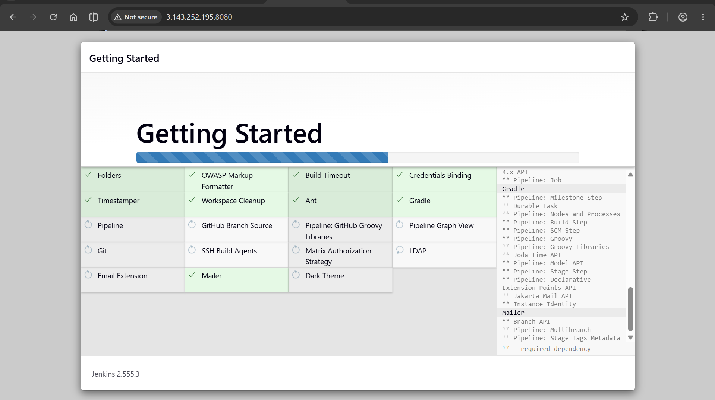

IAM Role attached to EC2 with CloudWatchAgentServer Policy
Role-
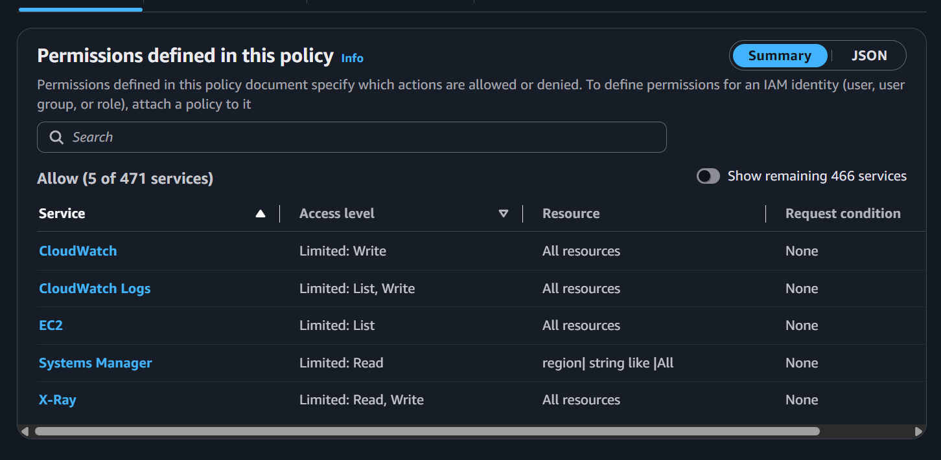

Attached –
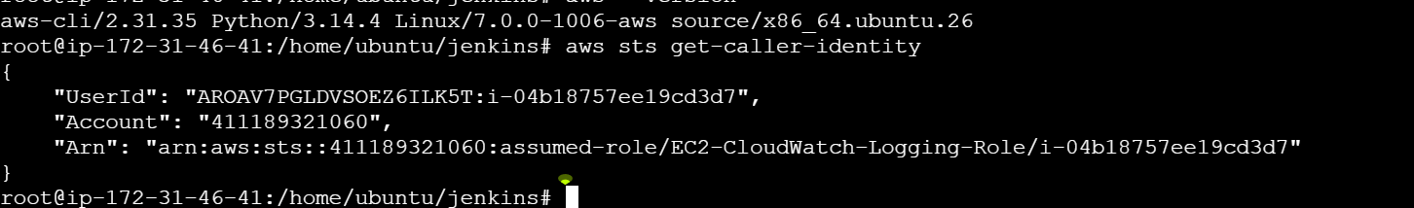

Scripts –
Monitoring Script
#!/bin/bash

LOG_FILE="/var/log/jenkins_monitor.log"

STATUS_FILE="/home/ubuntu/jenkins/status/last_status"
START_FILE="/home/ubuntu/jenkins/status/ast_start_time"

TIME=$(date '+%Y-%m-%d %H:%M:%S')

CURRENT_STATUS=$(systemctl is-active jenkins)

# First execution
if [ ! -f "$STATUS_FILE" ]; then
echo "$CURRENT_STATUS" > "$STATUS_FILE"
fi

PREVIOUS_STATUS=$(cat "$STATUS_FILE")

# Status Changed

if [ "$CURRENT_STATUS" != "$PREVIOUS_STATUS" ]; then

if [ "$CURRENT_STATUS" = "active" ]; then

echo "$TIME | Jenkins UP" >> "$LOG_FILE"

aws cloudwatch put-metric-data \
--namespace JenkinsMonitoring \
--metric-name JenkinsStatus \
--value 1

else

echo "$TIME | Jenkins DOWN" >> "$LOG_FILE"

aws cloudwatch put-metric-data \
--namespace JenkinsMonitoring \
--metric-name JenkinsStatus \
--value 0

fi

echo "$CURRENT_STATUS" > "$STATUS_FILE"

fi

# Restart

if [ "$CURRENT_STATUS" = "active" ]; then

CURRENT_START=$(systemctl show jenkins --property=ActiveEnterTimestamp --value)

if [ ! -f "$START_FILE" ]; then
echo "$CURRENT_START" > "$START_FILE"
fi

PREVIOUS_START=$(cat "$START_FILE")

if [ "$CURRENT_START" != "$PREVIOUS_START" ]; then

echo "$TIME | Jenkins RESTARTED" >> "$LOG_FILE"

aws cloudwatch put-metric-data \
--namespace JenkinsMonitoring \
--metric-name JenkinsRestart \
--value 1

echo "$CURRENT_START" > "$START_FILE"

fi

fi

Daily Report Script –
#!/bin/bash

LOG_FILE="/var/log/jenkins_monitor.log"

UP=$(grep -c "Jenkins UP" "$LOG_FILE")
DOWN=$(grep -c "Jenkins DOWN" "$LOG_FILE")
RESTART=$(grep -c "Jenkins RESTARTED" "$LOG_FILE")
Echo “Jenkins Report on ${date}”
Echo “Jenkins up events = $UP”
Echo “Jenkins down events = $DOWN”
Echo “Jenkins restart events = $RESTART”

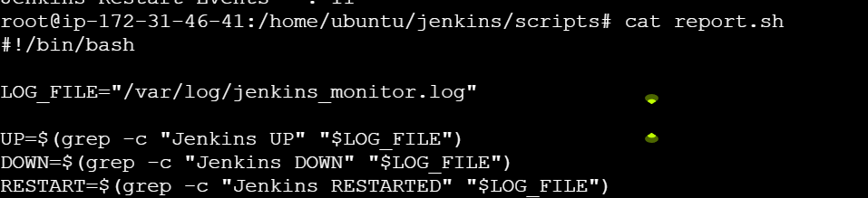

Crontab (Cronjob schedule)
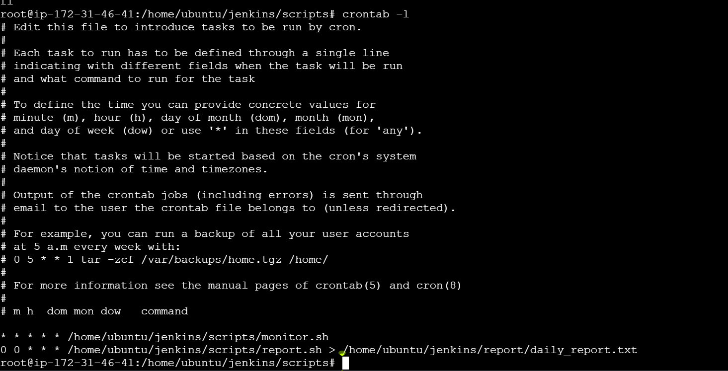

AWS SNS (For Notification)
Topic
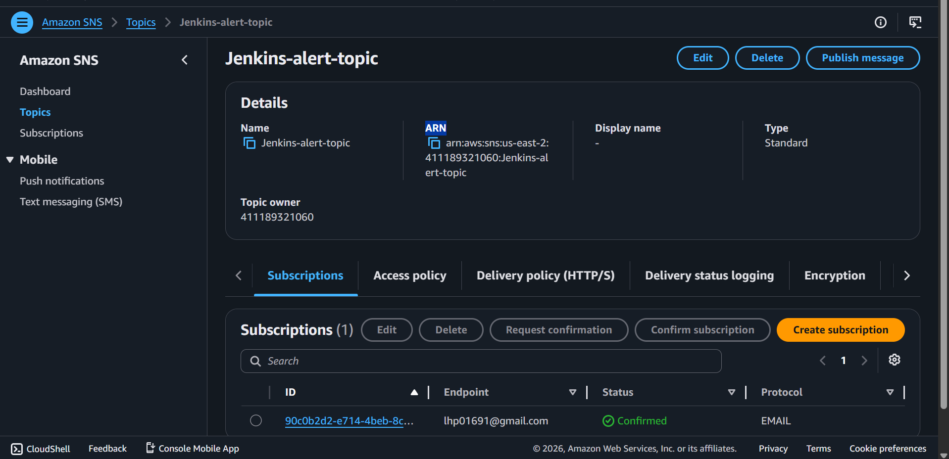
Subscription
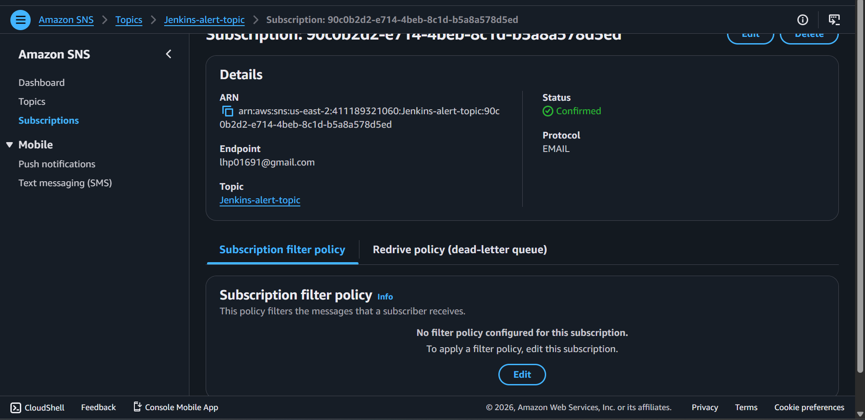

AWS CloudWatch for Monitoring and Alerting

Custom Metrics
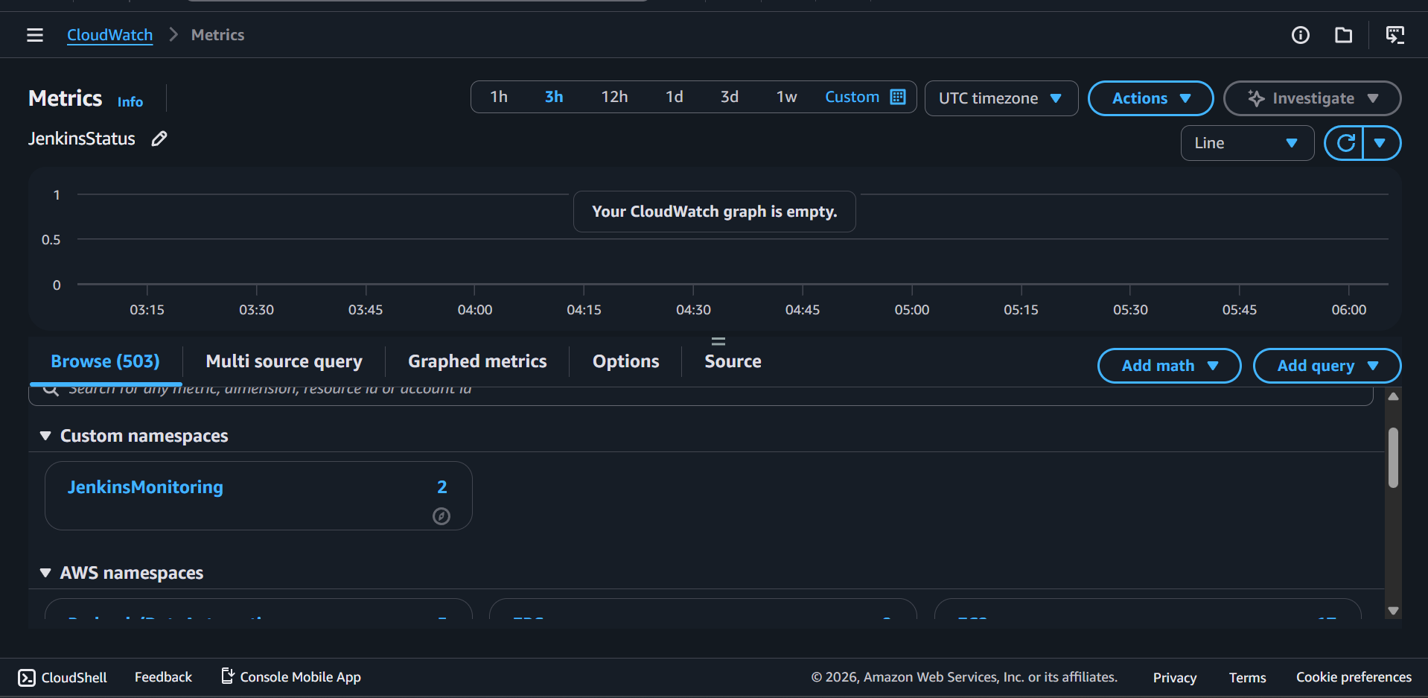
JenkinsStatus
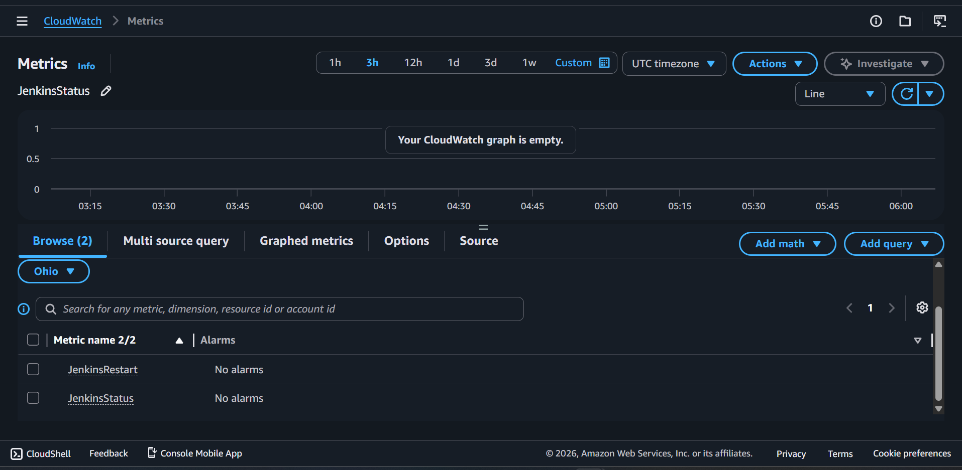
Running = 1
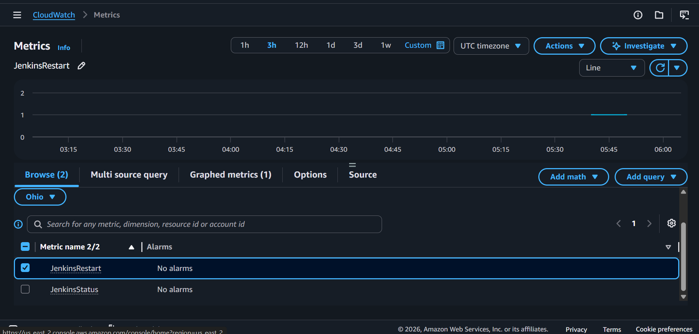

Down = 0
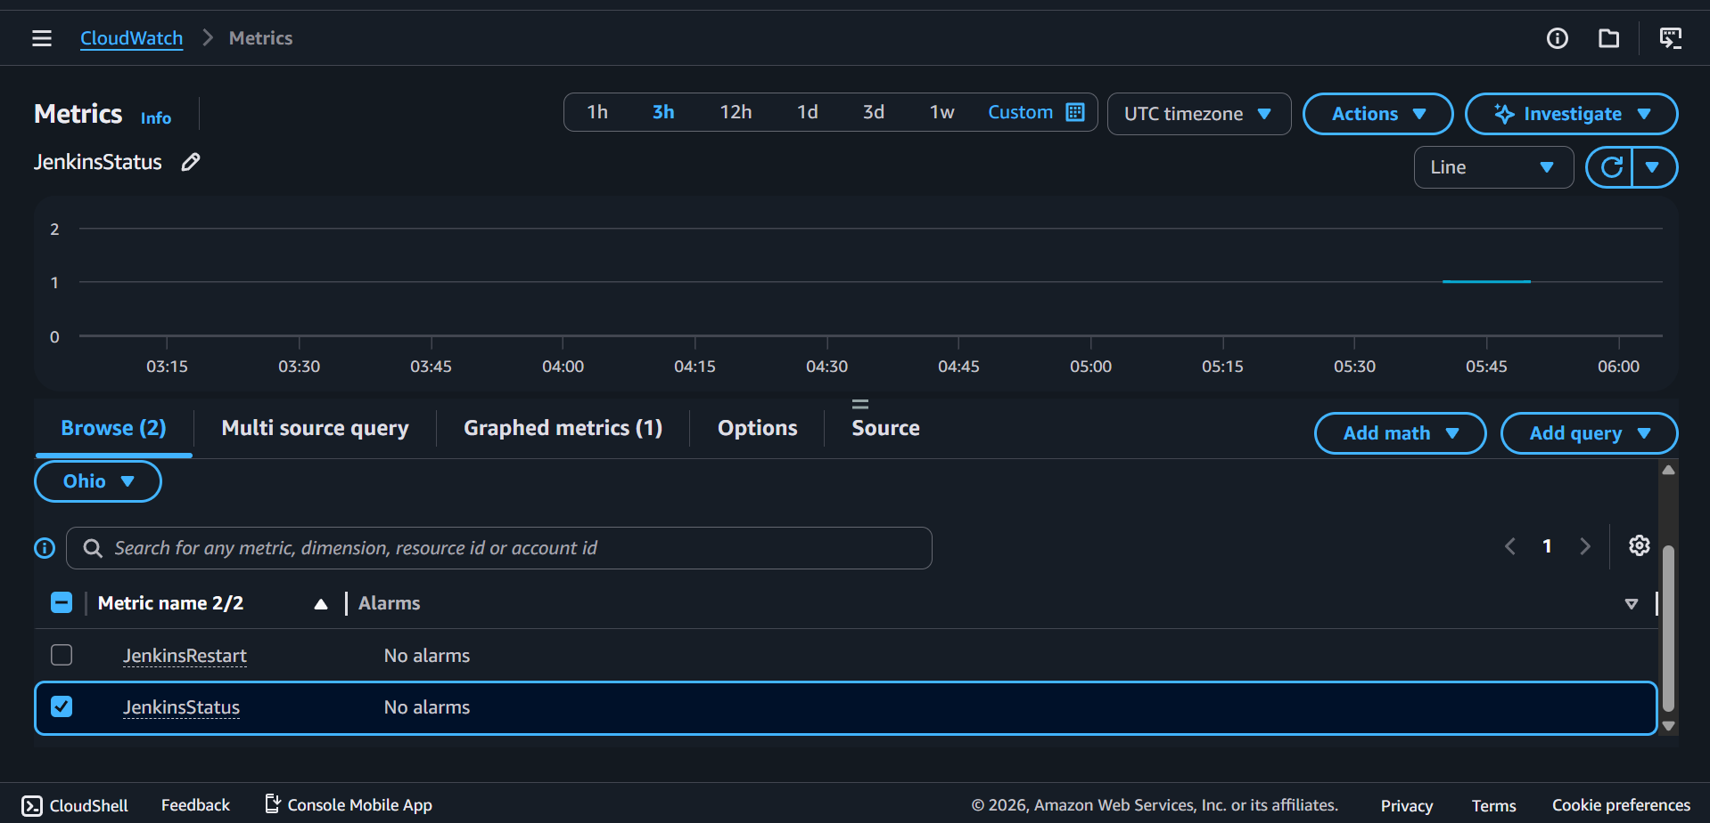

AWS Cloudwatch Alarm
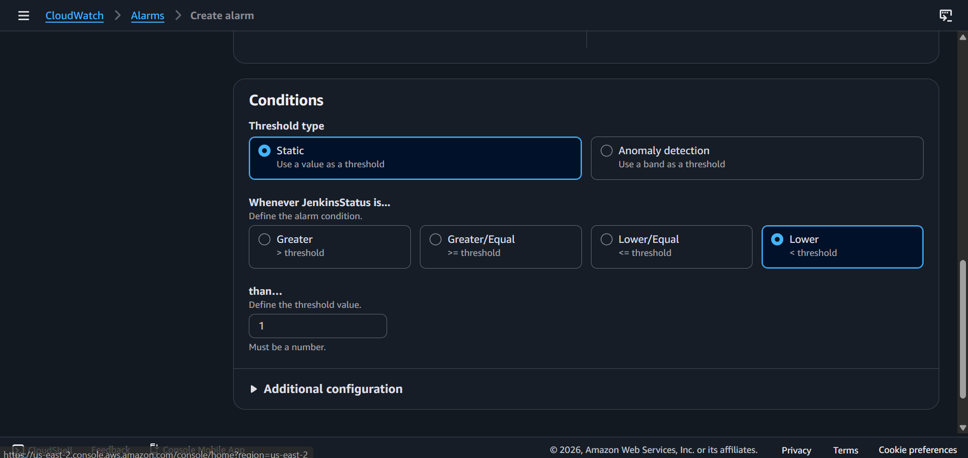
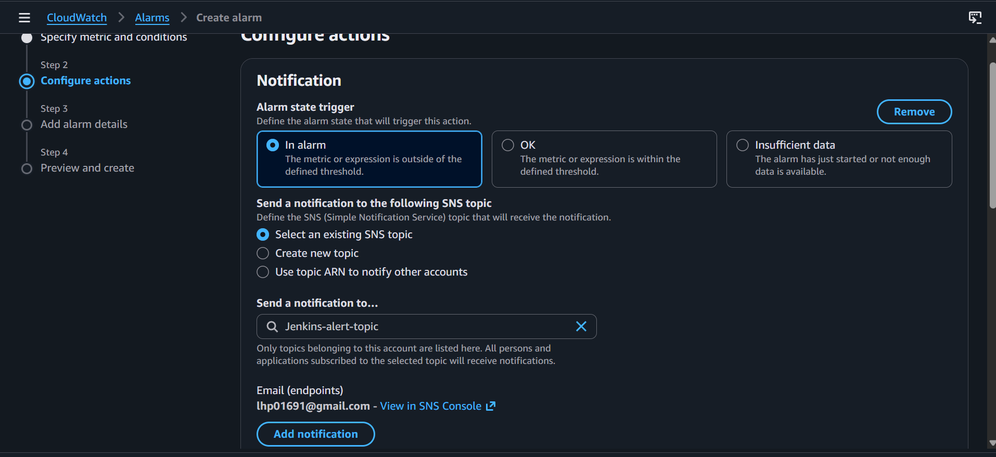
Jenkins Down alarm
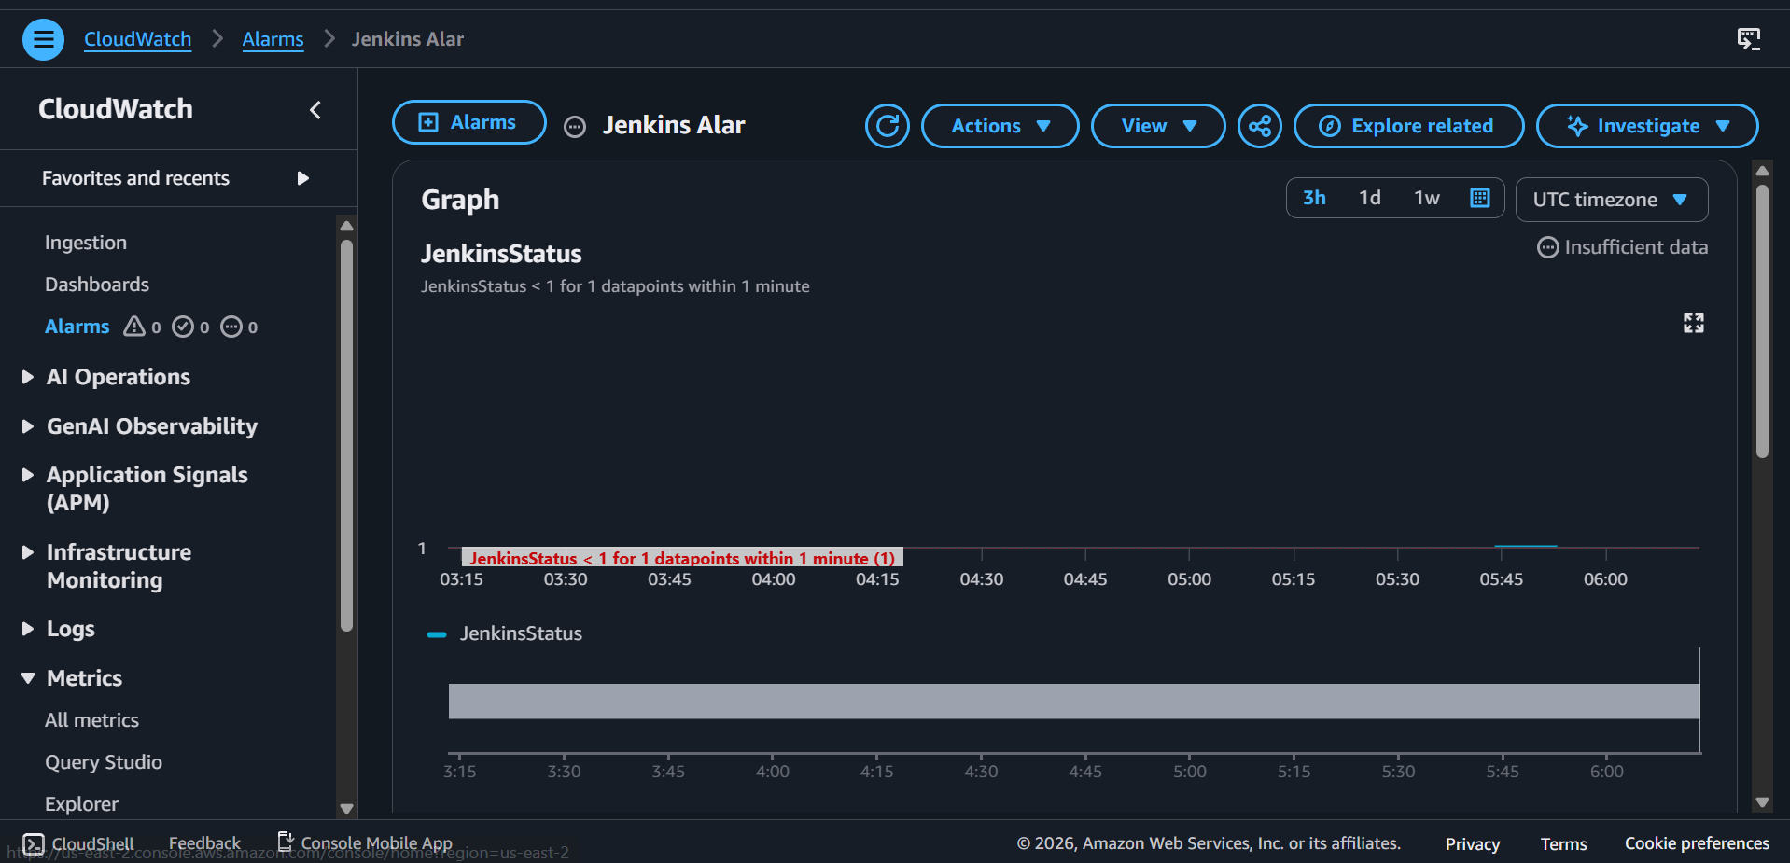

Jenkins Restart alarm
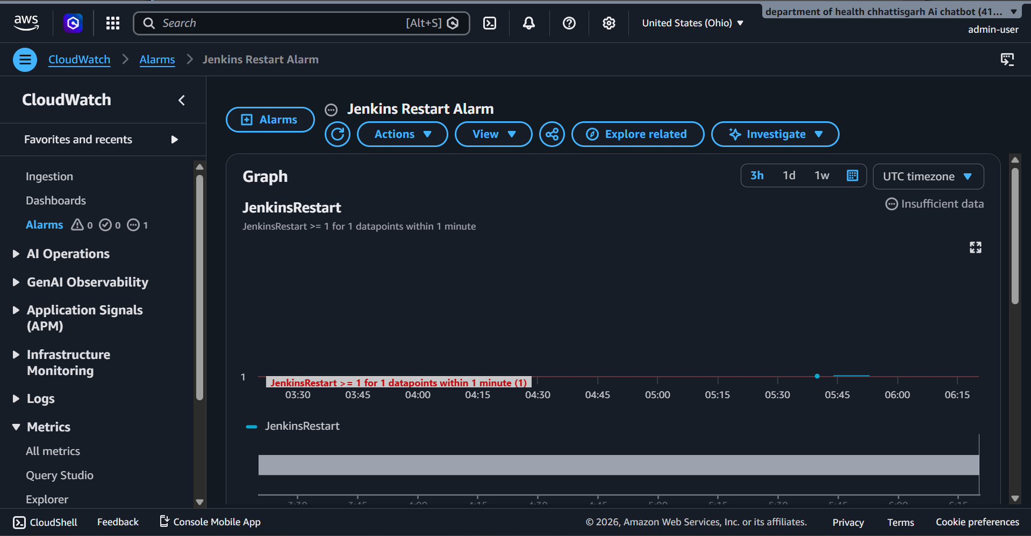

Jenkins Monitor Log
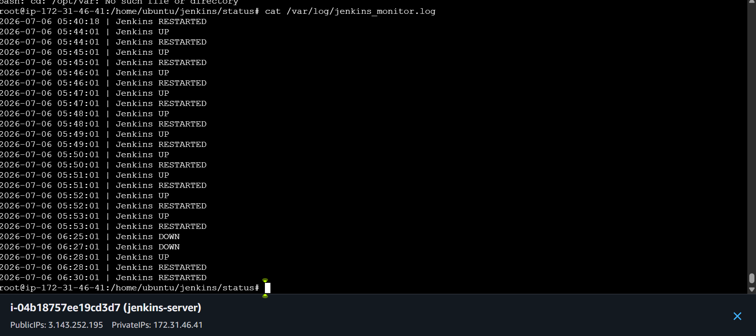
Last start time file
Last status file
Output Email –
Down Alert
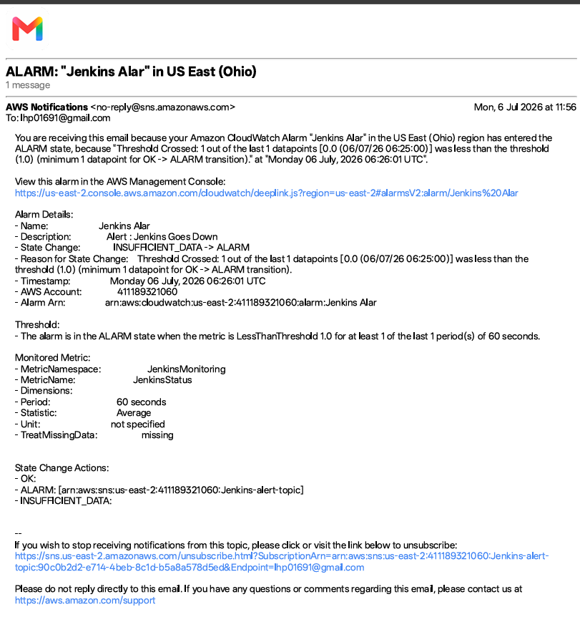

Restart Alarm
